Project Planning & Management

- Project Proposal – Overview of the project, objectives, and scope.

Overview: This project aims to design, develop, and deploy a cloud-based, production-grade system capable of detecting anomalies in real-time from streaming IoT time-series data (e.g., temperature, pressure, vibration, or other sensor readings from industrial equipment, manufacturing lines, or smart infrastructure).
The system will ingest continuous sensor streams, apply machine learning models to identify abnormal patterns that may indicate equipment failure, safety risks, or process deviations, generate immediate alerts, visualize insights on a real-time dashboard, and incorporate monitoring and automated model retraining mechanisms to maintain accuracy over time.
The entire solution will be built and deployed on Microsoft Azure services to demonstrate modern cloud-native MLOps practices.

Objectives:

Main Objectives
Develop a complete real-time anomaly detection and alerting solution for IoT time-series streams with production-grade characteristics.

Specific Objectives
- Collect, preprocess, and explore real or simulated multi-sensor time-series data.
- Build and compare effective anomaly detection models suitable for streaming inference.
- Deploy the model for real-time scoring using Azure cloud services.
- Implement alerting mechanisms and a live monitoring dashboard.
- Apply MLOps practices: experiment tracking, data/model drift detection, performance monitoring, and automated retraining triggers.
- Document the architecture, challenges, results, and prepare a live demonstration.
Scope:
In Scope:
Ingestion of streaming data (Azure Event Hubs or similar)
Time-series preprocessing (windowing, feature extraction, smoothing, lag/rolling features)
Anomaly detection modeling (e.g., Isolation Forest, LSTM Autoencoder, and/or statistical/threshold-based methods)
Real-time inference pipeline
Alert generation (e.g., via Azure Monitor / Logic Apps)
Real-time visualization dashboard (Power BI, Grafana, or Streamlit)
Basic drift detection and automated retraining concept
End-to-end demonstration with simulated or public datase
Out of Scope:
Edge deployment (inference on device)
Very advanced models (e.g., large-scale Transformers or federated learning)
Full production security hardening (RBAC, encryption at rest in depth)
Integration with real physical IoT devices (simulation only)
Very large-scale load testing (>10,000 events/sec)

- Project Plan – Timeline (Gantt chart), milestones, deliverables, and resource allocation.

Timeline (Gantt chart):
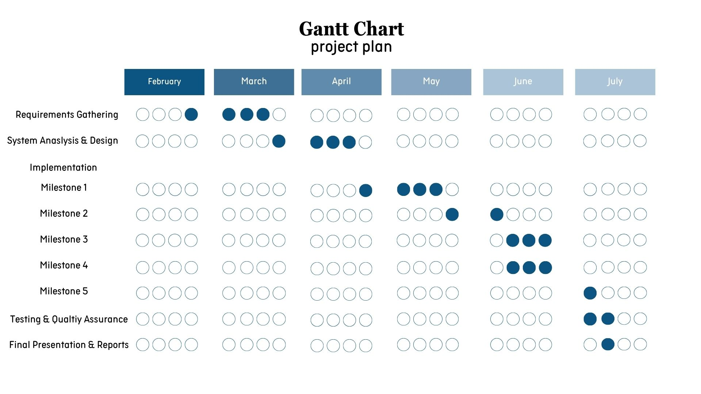

Milestones and Deliverables:
Milestone 1: Data Collection, Preprocessing, and Exploration
Objectives
• Collect real or simulated time‑series IoT data
• Preprocess and explore seasonal patterns and noise
Tasks
1. Data Collection:
a. Ingest data from multiple sensors (temperature, pressure, etc.) via simulated streams or public IoT datasets.
b. Store raw data in Azure Data Lake or Blob Storage.
2. Data Preprocessing:
a. Handle missing values, smoothing, and window segmentation.
b. Create engineered features (lag features, rolling means).
3. Exploratory Data Analysis (EDA):
a. Analyze trends, seasonal effects, and noise patterns.
b. Identify baseline normal behavior and potential anomalies.
Deliverables
• Cleaned and Structured Time‑Series Dataset
• Data Preprocessing Pipeline Documentation
• EDA Report with Visualizations

Milestone 2: Model Development & Evaluation
Objectives
• Train reliable anomaly detection models suitable for streaming data
Tasks
1. Model Development:
a. Implement models such as LSTM Autoencoders, Isolation Forests, or Prophet‑based threshold detection.
2. Evaluation:
a. Evaluate using precision, recall, F1‑score for anomaly classes.
b. Test on held‑out test sets and synthetic anomalies.
3. Optimization:
a. Adjust thresholds and retrain pipelines for robustness.
Deliverables
• Trained Anomaly Detection Models
• Model Evaluation Report

Milestone 3: Advanced Techniques & Cloud Integration
Objectives
• Deploy the model in real time on Azure
Tasks
1. Cloud Deployment:
a. Use Azure Stream Analytics and Azure Functions for real‑time scoring.
b. Containerize model inference with Docker deployed through Azure Container Instances.
2. REST API:
a. Build a REST API for real‑time anomaly scoring.
3. Integration:
a. Integrate with Azure Event Hubs for stream ingestion.
Deliverables
• Deployed Real‑Time Anomaly Detection Service
• Real‑Time API Endpoints

Milestone 4: MLOps, Monitoring, & Dashboard
Objectives
• Implement production‑grade monitoring, alerts, and retraining automation
Tasks
1. MLOps Tracking:
a. Track model versions and experiments with MLflow or Azure ML.
2. Monitoring:
a. Use Azure Monitor and custom metrics for drift and performance monitoring.
3. Dashboard:
a. Build a dashboard (Power BI or Grafana) showing anomaly rates in real time.
4. Retraining Plan:
a. Set up scheduled retraining pipelines triggered by drift detection.
Deliverables
• Monitoring & Alerting Setup
• Dashboard & KPI Visualization
• MLOps Pipeline Documentation

Milestone 5: Final Documentation & Presentation
Objectives
• Summarize and demonstrate end‑to‑end solution
Tasks
1. Final Report:
a. Document pipeline, deployment, challenges, and business impact.
2. Presentation:
a. Live demo of streaming anomaly detection with alerts and dashboards.
3. Future Enhancements:
a. Propose edge deployment optimization or predictive maintenance features.
Deliverables
• Final Project Report
• Final Presentation Deck
• Future Improvements Document

Resource allocation:
- Python
- Pandas & Numpy
- Matplotlib & Seaborn
- Scikit-learn
- TensorFlow / PyTorch
- Joblib/Pickle
- Azure Blob Storage / Data Lake
- Azure Stream Analytics & Azure Functions
- Docker
- REST API & Postman
- Azure Event Hubs
- MLflow or Azure ML
- Azure Monitor
- Dashboard using Power BI or Grafana
- Github and Git

- Task Assignment & Roles – Defined responsibilities for team members.

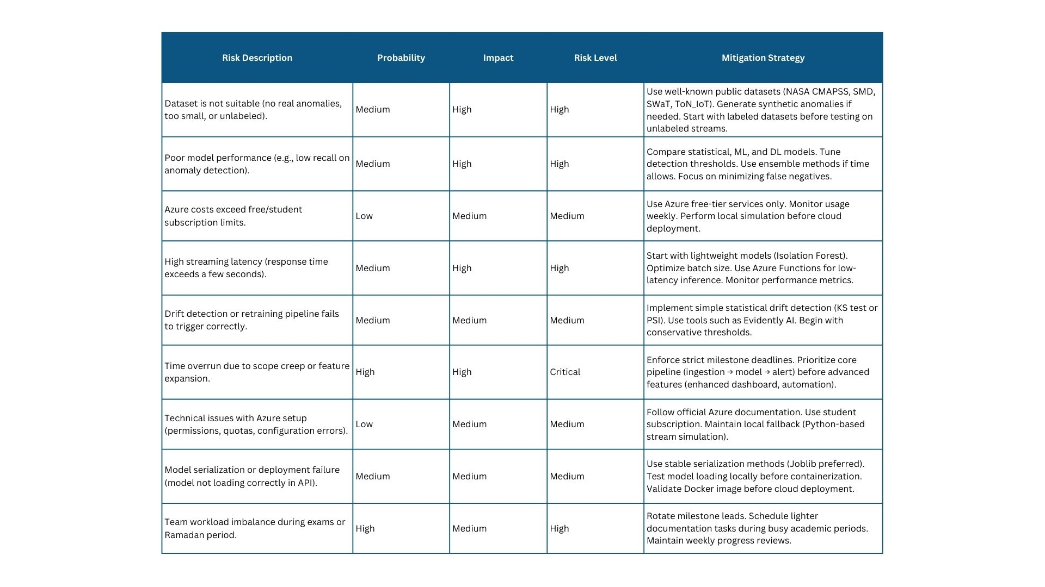
- Risk Assessment & Mitigation Plan – Identifying risks and solutions.

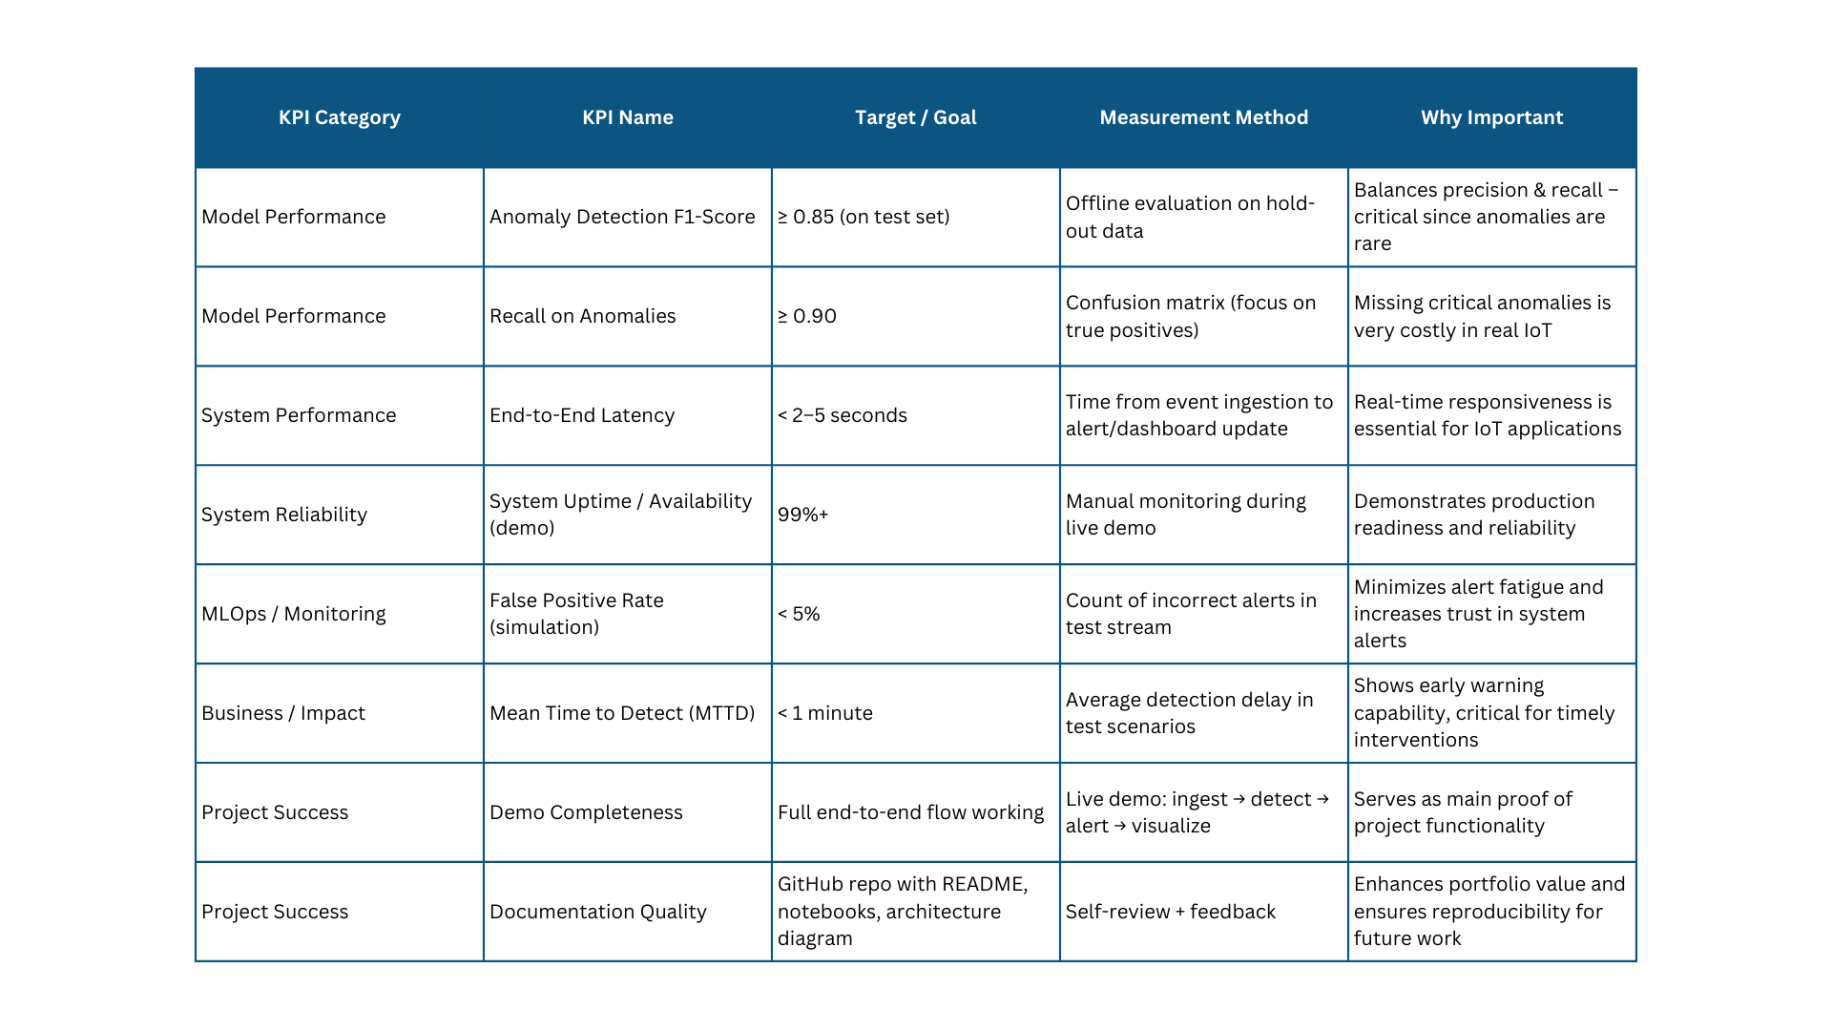
- KPIs (Key Performance Indicators) – Metrics for project success (e.g., response time, system uptime, user adoption rate).

